Optimization

Assignment 4

Qian Zhang

2/13/2020

Question 1:

I searched for the top ETFs in United Kingdom and found a list of U.S. equity ETFs that maintain significant exposure to stocks listed in United Kingdom (https://etfdb.com/etfs/country/united-kingdom/). I picked the first top five: iShares MSCI United Kingdom ETF(EWU), SPDR Blackstone/ GSO Senior Loan ETF(SRLN), Invesco CurrencyShares® British Pound Sterling Trust(FXB), Franklin FTSE United King SRLN dom ETF(FLGB), iShares MSCI United Kingdom Small-Cap ETF(EWUS). However, this website does not have any historical price data. Therefore, I searched each of the ETFs on yahoo finance, and downloaded the weekly historical price from Dec 03, 2018 - Dec 03, 2020 of each ETFs as CSV file.

Question 2:

I created an Excel file and copied all the **Weekly Price ($)** of all five ETFs into the Excel file. For each column of weekly price, sorted by date, I calculated the **Weekly Rate of Return(%)** using the function **(price – price of last week)/price of last week** for each of five ETFS, and calculated the average of weekly rate of return and saved it as **Expected Asset Return Rates(%)**. I also calculated the standard deviation of weekly price of each ETFS by using function STDEVA (the inputs are all the weekly prices of each ETFs), and the Covariances of each pairs of ETFs by using function COVAR (the inputs are the weekly prices of each two pairs of ETFs).

Question 3:

To solve the Markowitz problem, I chose the return maximization formulation, which aims to maximize expected returns, with constraints of budget constraint, maximum acceptable risk, and non-negativity. For the maximum acceptable risk, I started with 0, incremented 0.5 every time and solved the corresponding maximum expected returns. I found that for maximum acceptable risk to be 17.5 onwards, the expected return reaches its maximum. The plot of the efficient frontier is attached below:

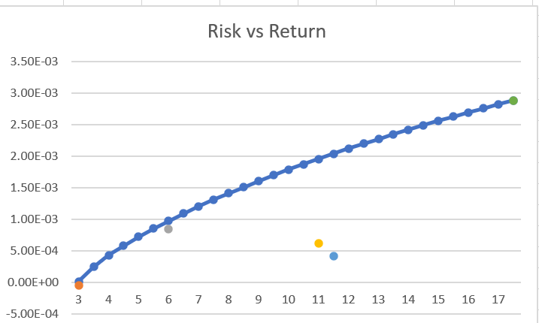

The three optimal portfolio composition for three selected portfolios:

|  |  |  |  |  |  |
| --- | --- | --- | --- | --- | --- |
|  | EWU | EWUS | SRLN | FXB | FLGB |
| Low return/Low Risk | 0% | 12% | 78% | 9.2% | 0.8% |
| Medium return/ Medium Risk | 0% | 59% | 0% | 3.3% | 37.7% |
| High return/High Risk | 0% | 100% | 0% | 0% | 0% |

I will choose the medium return/medium risk portfolio, since the low return/low risk is heavily depended on SRLN, while the high return/high risk is heavily depended on EWUS. Therefore, both the portfolios are too risky. However, the medium return/medium risk is more diverse, hence it is more preferred.

Question 4: I will set ten additional constraints to each of the five decision variables, so each of the five decision variables, ie the weight of each ETFs, is larger than 0.1 and also smaller than 0.35.

Question 5: Before I start to practically implement a portfolio, which is based on the past data, I will implement a simulation first and see whether my portfolio does generate revenue. For example, whether the variance of simulation of the actual market data varies significantly from the portfolio variance. If so, I will look back to the portfolio to see whether there are some factors that I should have considered while designing the portfolio.